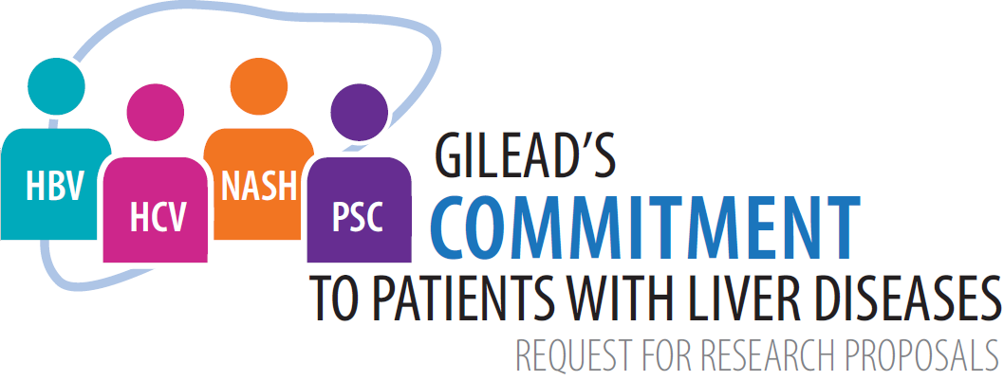
HBV CARE Program:
HBV - Linkage to CARe & Epidemiology in Special Populations

Please answer all sections below and submit the completed form as a Word file to HBV-CARE@gilead.com with the email subject heading “HBV CARE LOI – [Principal Investigator Name, Organization Name].” Submitted Letters of Intent (LOIs) will be reviewed on a rolling basis and either approved for full application submission or declined. Full applications will be reviewed similarly and projects will be accepted until program funds are exhausted. Note that program funds will not be allocated per month of the submission window. If you have any questions about the application form, please ask your local Gilead Medical Scientist or email HBV-CARE@gilead.com.

Investigator/Sponsor Information
Principal Investigator
Telephone
Email address
Curriculum vitae attached | Yes No
Legal Sponsor / Primary Site
Address
City, State, Zip/Province, Postal code
Country
Description of Organization/Institution | Hospital  Academic Research  Government Entity  Other: ______________________
Name of Subsite (if applicable)
Address
City, State, Zip/Province, Postal code
Country
Sponsor IRB/REB (check one) | Local IRB/REB Central IRB/REB
Name of ethics committee
Does IRB/REB require a fully executed  contract prior to review? | Yes No
Average time from submission to  approval | _____ weeks
Sponsor Contact for Submission and Negotiation of Investigator-Sponsored Research Contract
Telephone
Email Address
Has your institution applied for or received funding from Gilead in the past? | Yes No
Gilead Contact (if applicable)
How did you hear about STAT? (check  all that apply) | Colleague  Gilead Contact (e.g. Medical Scientist, Medical Manager)  Name: ________________________  World Hepatitis Alliance  NOhep  NATAP  Other: __________________
Proposal
Study Title
Estimated Budget Requested from Gilead
Any proposal greater than $150,000 should be
discussed with your Gilead Medical Scientist
prior to submission.. Must include overhead
costs and all taxes if applicable. Overhead in
excess of 30% will not be approved.
Budget Considerations (check
all that apply)
Subject-related costs | Yes No
Study-related personnel | Yes No
Diagnostic fees and services | Yes No
Data management expenses | Yes No
Publication costs (e.g., preparation of  manuscript, travel, etc.) | Yes No
IRB/REB review fees | Yes No
Overhead | Yes No
Overhead Cap Letter Signed and Attached  Must be signed by Sponsor institution’s budget  officer or other designee. Signed letter must be  attached before LOI is reviewed. | Yes No
Funding Requested From Other Sources?  If yes, include name of source and amount in  USD. | Yes: ________________________________  No
Study Design (check all that apply) | Prospective  Retrospective  Observational  Interventional  Modelling
Plan to Collect Protected Health Information | Yes No
Publication Plan (check all that  apply) | Conference  Manuscript
Do you plan to present findings to  policymakers (local, regional, national)? | Yes No
Research Plan
Type your responses to Questions 1 through 5 in this document. Please limit your response in this entire
section to 1,000 words.

- Scientific rationale

- Primary objective

- Research methods

- Describe which, if any, policymakers you to plan to engage and how.

- Study Duration (in months)

By entering my name below, I hereby certify that the above statements are true and correct to the best of my knowledge.

Name & Title Date

